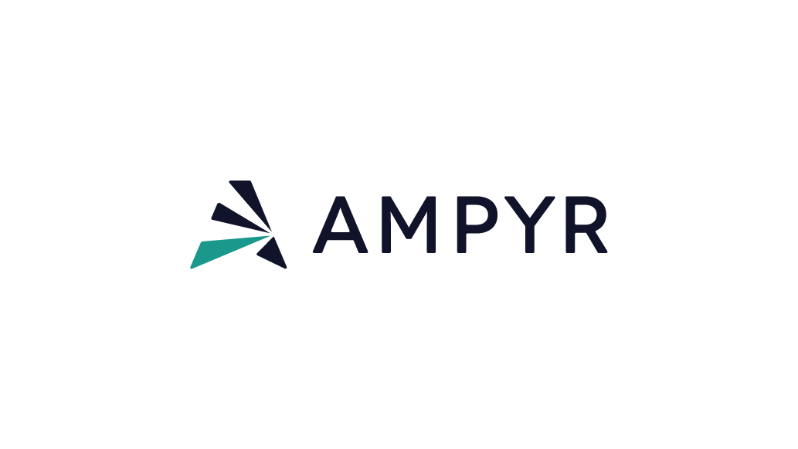

Community Benefit fund guidelines
November 2025

ELIGIBILITY
Applicants to the Community Fund should be either a:
- Non-profit organisation
- School or educational department/group, or
- A local organisation that provides key community and/or environmental services
Businesses that provide services to the community may apply for funding to support a project that is run on a not-for-profit basis and clearly benefits the community.
To be considered for the Community Fund, projects must be located in or provide significant and traceable services to communities near to the Project.
The applicant must:
- Be a registered organisation
- Have an Australian Business Number
- Have an Australian bank account
- Be “Project Ready” – this means projects MUST start within the next 12 months, if they have not already done so


As a general rule AMPYR Australia will NOT fund:
- Completed projects
- Rents or other running/overhead costs
- Activities or services for individual/ private benefit or operating on a for-profit basis
- Political parties, organisations or campaigns, including registered lobbyists
- Religious or spiritual groups, except where the request is inclusive of the wider community
- Funding of interstate or overseas travel or conference organisation
- Requests for charitable donations or advertising
- Projects that are in direct opposition to renewable energy
- Funding goods or activities related to use of alcohol, tobacco, drugs, gambling or any illegal activity
- Any other activity deemed to be unethical, unsafe or unsuitable by AMPYR Australia
- Projects and initiatives that are the sole responsibility of the Federal, State or Local Government. An exception exists where entities are individually incorporated but serve as part of a broader government service (eg volunteer fire brigade, SES units).

AMPYR Australia will consider each community sponsorship proposal, however decisions are discretionary, and sponsorships are limited.


Based on community feedback and local needs, preference may be given to applications that relate to the following categories.
Across these areas, AMPYR will prioritise projects that provide lasting benefits for the community.

1) COMMUNITY ENGAGEMENT/ENRICHMENT
Examples include community-wide events, youth activities and programs.

2) EDUCATION PROGRAMS
Examples include educational programs and tours, educational resources, scholarships and donations towards students.

3) HEALTH AND WELLBEING
Examples include initiatives that promote/enhance healthy living, health care, childcare, mental health care or assistance to disadvantaged groups, support during an emergency.

CATEGORIES



4) ENVIRONMENT AND SUSTAINABILITY PROGRAMS
Examples include seed planting, native wildlife protection, habitat conservation, land care.

5) FIRST NATION INITIATIVES
Projects that support First Nations initiatives regarding education, health, culture and wellbeing.

6) ARTS AND CULTURE
Examples include music events, community festivals, gala nights, community lunches.

7) SPORTING GROUPS
Projects that support and promote sporting and recreational activities and progression.

8) INFRASTRUCTURE/REFURBISHMENT
Examples include upgrading public community facilities, museums, wheelchair access.

AVAILABLE FUNDING
In general, applicants may be eligible to apply for up to $10,000 of funding per application. AMPYR will provide details about the timing of funding rounds, the extent of funds available, and any identified focus areas for funding through the public promotion of the Project.

HOW TO APPLY
Before applying, you must read and understand these guidelines and the Application Form.
To apply you must:
- Complete the online Application Form by clicking by visiting the Project website or request an Application form by emailing community@ampyrenergy.com
- Provide all the information requested
- Address all eligibility criteria
- Include all necessary attachments

Applicants are responsible for ensuring that their application is complete and accurate. Giving false or misleading information will exclude your application from further consideration.
If you find an error in your application after submitting it, please contact us immediately at community@ampyrenergy.com.
You cannot change your application after the closing date and time.
If we find an error or information that is missing, we may ask for clarification or additional information from you that will not change the nature of your application. However, we can refuse to accept any additional information from you that would change your submission after the application closing time.

SUCCESSFUL GRANT APPLICATIONS
Successful applicants must enter into an agreement with AMPYR Australia.
A grant agreement must be executed by both parties before we can make any payments. We are not responsible for any of your expenditure until a grant agreement is executed. If you choose to start your grant activities before you have an executed grant agreement, you do so at your own risk.
AMPYR Australia may recover grant funds if there is a breach of the grant agreement.
The offer may lapse if both parties do not sign the grant agreement.

